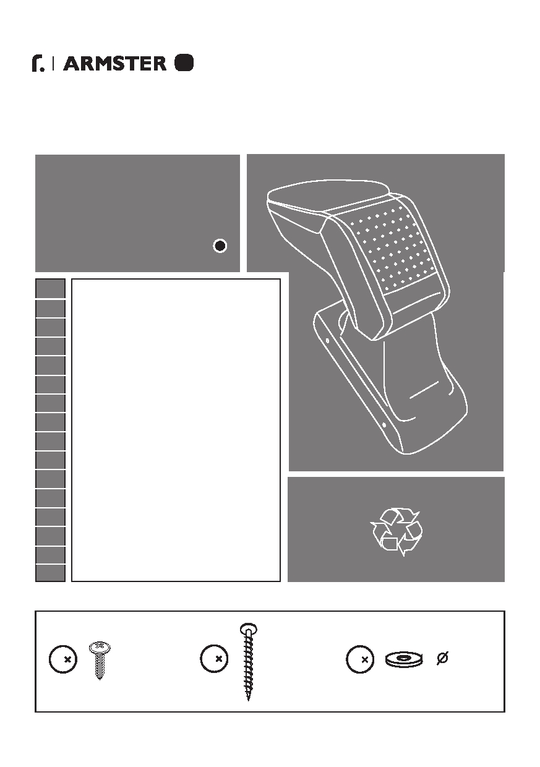

The Standard Armrest
s
MOUNTING NOTE

ΟΔΗΓΙΕΣ ΤΟΠΟΘΕΤΗΣΗΣ
www.auto-parts.gr

ARMSTER S:

V00586

EN
DFE
NL
I
P
H
CZ SK SL
HR RO

CENTER ARMREST
MITTELARMLEHNE
ACCOUDOIR CENTRAL
APOYABRAZOS CENTRAL
CENTER CONSOLE
APPOGGIA BRACCIO CENTRALE
CONSOLE
KARTÁMASZ
OPĚRKY RUKY
STREDOVA OPIERKA RUKY
NASLON ROKE
NASLON ZA RUKU
COTIERĂ

ABS
RU ПOДЛОКОТНИK
PL PODŁOKIETNIK
TR OTOMOBIL KOLÇAĞI

4 St 4,8x16 4 St 3,9x25 4 4,3x12

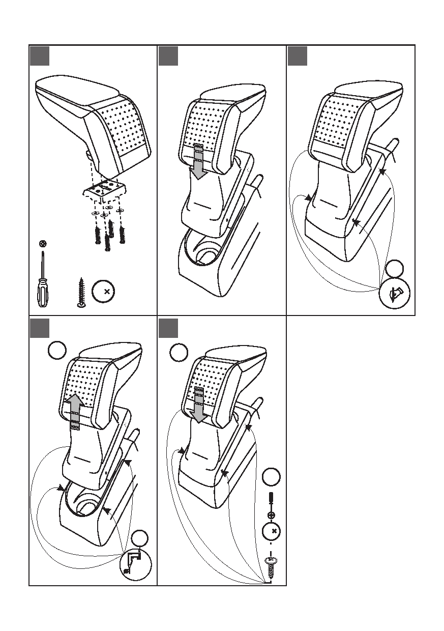
1 2 3

PH2

1
4 St3.9x25

4 5
1 1

2

4
2
St 4,8x16

3mm

4/6

